**Super Admin**

1. Profile
2. Summary
3. Community
4. Users
5. Error Log
6. Bug Reports
7. IPN Information
8. IPN Access
9. Settings
10. Features

**Profile:**

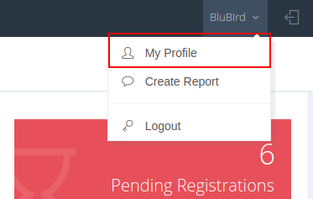

Here Super Admin can edit their profile information from this My Profile Menu.

**Summary:**

This is Summary page of this application:

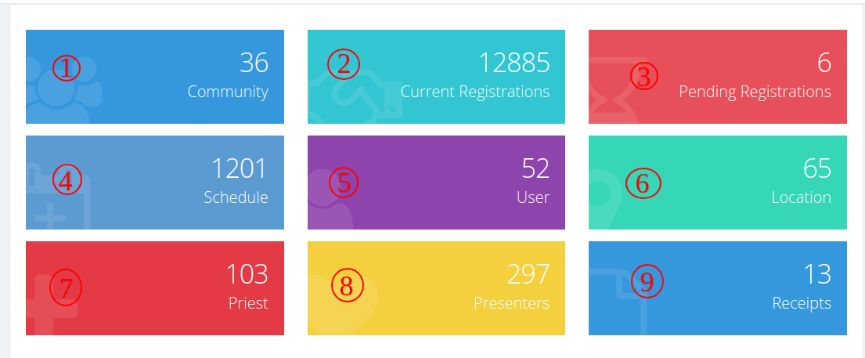

1. **Community:**

Here showing the total number of Community of this application.

1. **Current Registrations:**

Here showing the total number of registrations for all communities.

1. **Pending Registrations:**

Here showing the total number of pending registrations which payment not completed yet.

1. **Schedule:**

Here showing the total number of schedules of all communities.

1. **User:**

Here showing total number of Users for all communities

1. **Location:**

Here showing the total number of Locations for all communities.

1. **Prest:**

Here showing the total number of priests for all communities.

1. **Presenters:**

Here showing the total number of presenters for all communities.

1. **Receipts:**

Here showing total number of Receipts for all communities.

**Community**

This is the community page and this is the main part of this application. Here showing all community lists of this application.

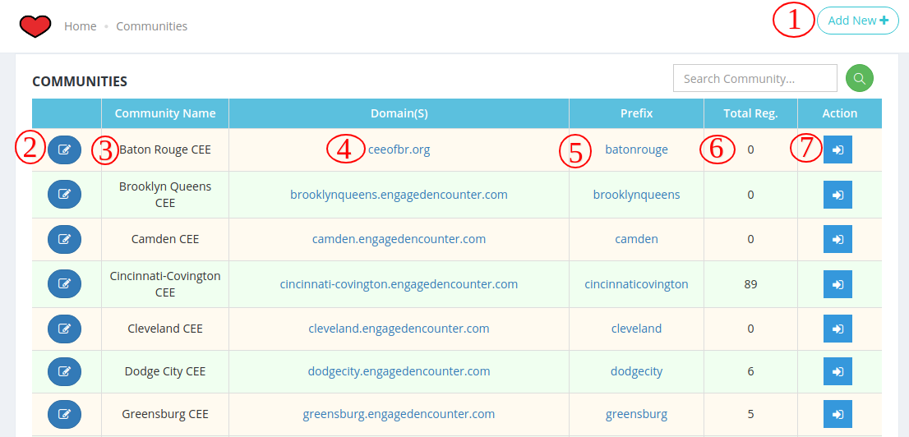

1. **Add New:**

Super admin can create a new Community. Create a new community, need a name, prefix and url. This field is mandatory.

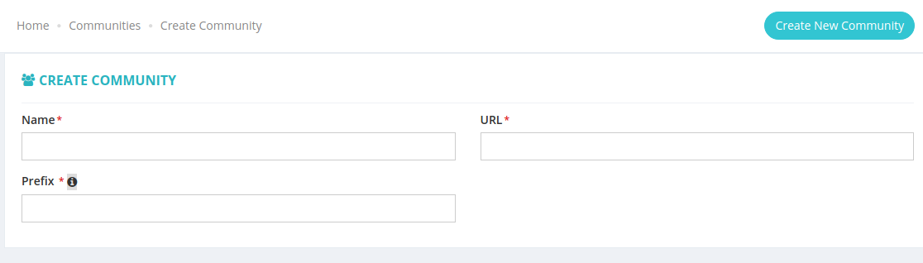

1. **Edit Community:**

Super admin can edit and update any Community information.

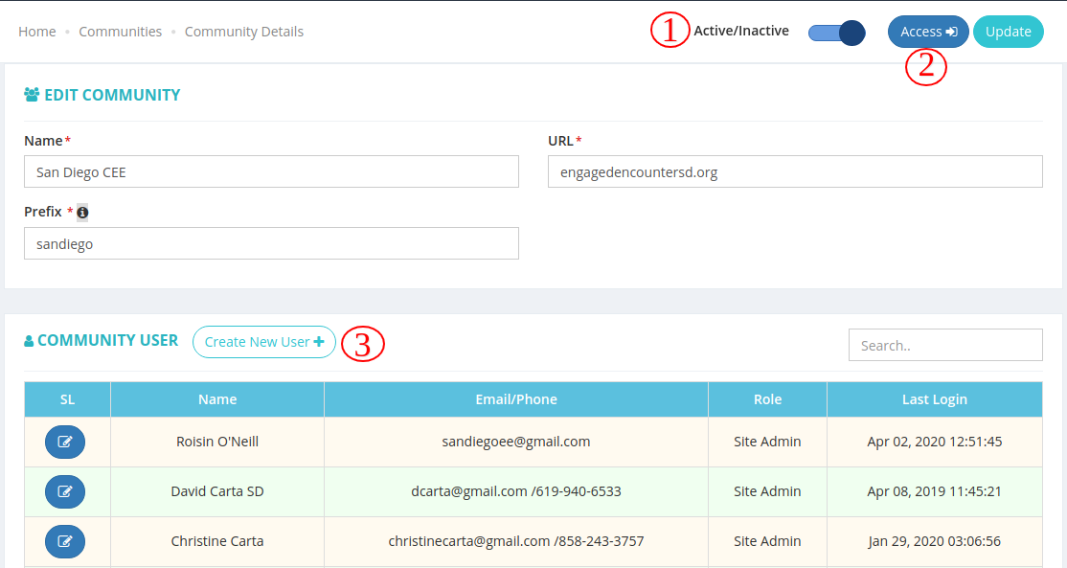

* 1. **Active/Inactive:**

If community Inactive users can’t login to community, if community active then users can login to community.

* 1. **Access:**

Here click to browse this application.

* 1. **Create New User:**

Here super admin can create new users for this community. All user lists showing this page for this community.

1. **Community Name:**

Here showing application name.

1. **Domain:** Community domain
2. **Prefix:** which are shown before the main domain.
3. **Total Registration:**

Here showing the total number of registration of this application.

1. **Action:**

Super admin can access a community of this button.

**Users**

This is the user list page all users and their information show this page.

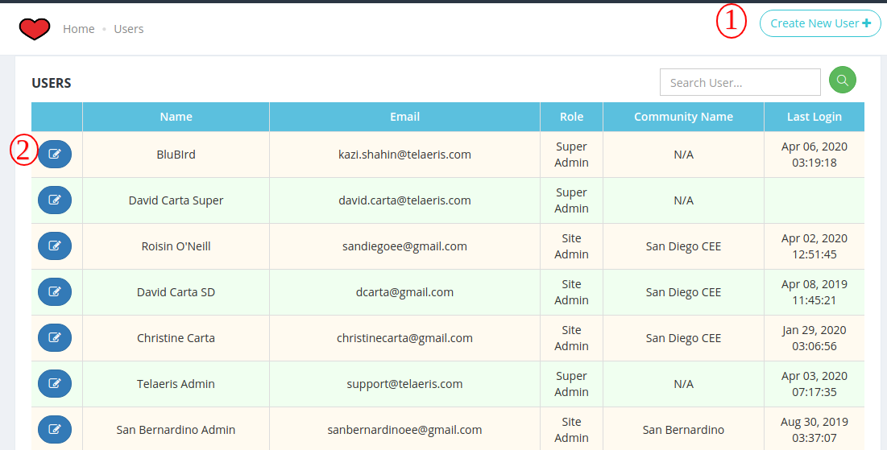

1. **Create User:**

This is a user creation page.two type of user can create from this page once is “Super Admin” and another one is “Site Admin”. Site admin should be one community. Here name, email, role, community is a mandatory field. Email is unique.

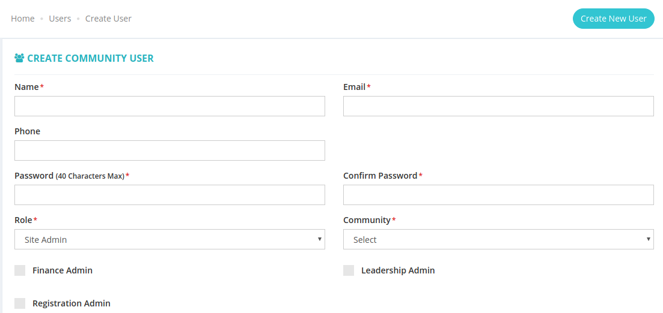

1. **Edit User:** In this page user information can be updated.
   1. **Update User:** Edit any user information and update user button click to update this user information.
   2. **Delete:** This button can delete current user.

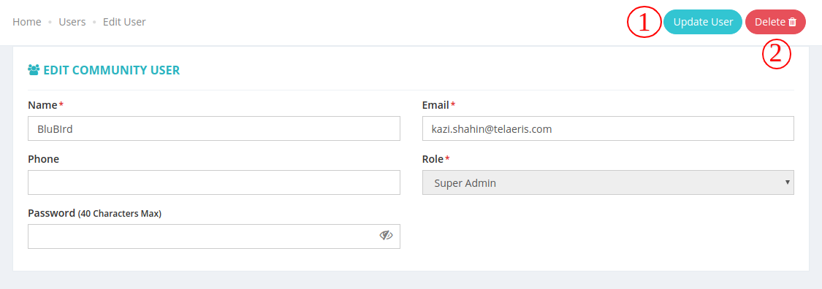

**Error Log**

This is the error log page all community system error stores in this page.

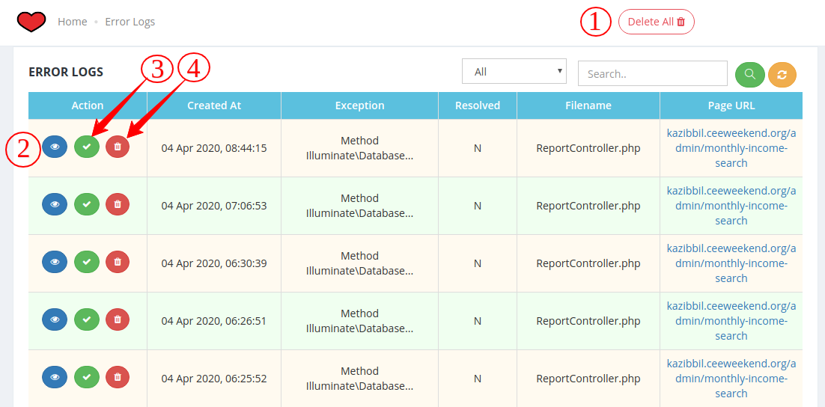

1. **Delete All:**

You can delete all buttons from this button.

1. **View Error Details:**

You can see error log details in this button, which page to come and which community.

1. **Resolve/Unresolve:**

Error made resolved and unresolved for this button.

1. **Delete:**

You can delete a single error for this button.

**Bug Reports**

This is a bug report page admin and users can report any bug or add note for improving this system.

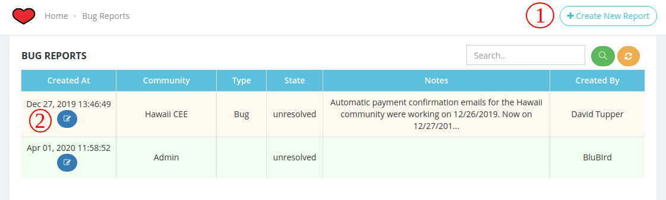

1. **Create New Report:** Create a new bug report when anyone faces a problem.report type, report notes and screenshot needed for creating bug reports.

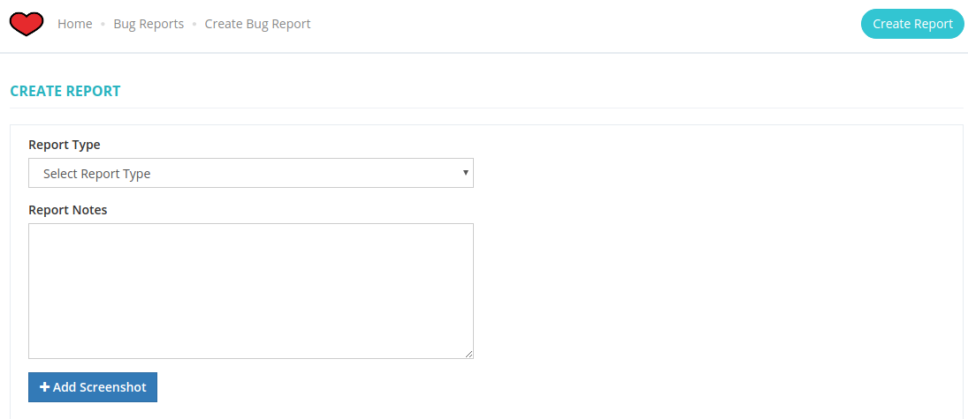

1. **Edit Report:** 
   1. **Delete:**

Super admin can delete any bug report.

* 1. **Resolve:**

Bug status can change via this button.

* 1. **Update Report:**

If need bug report information can be updated for this button.

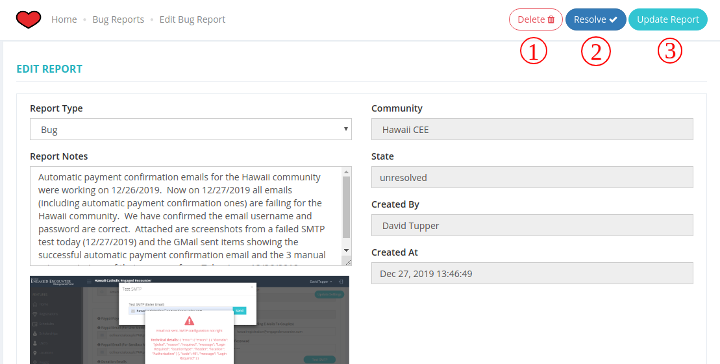

**IPN Information**

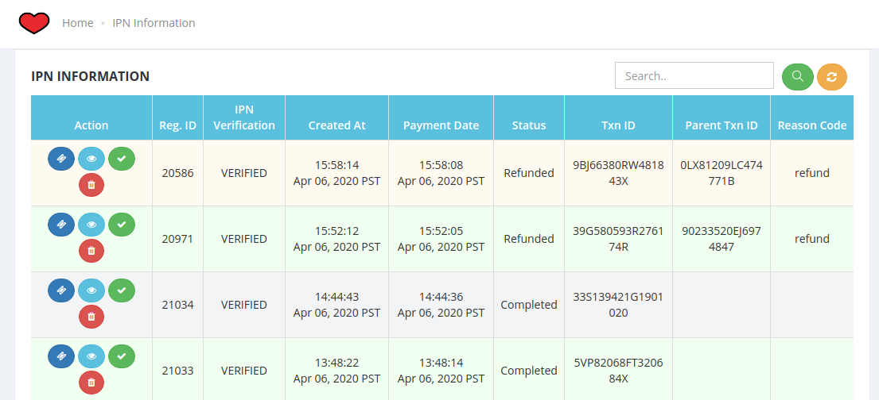

**IPN Access**

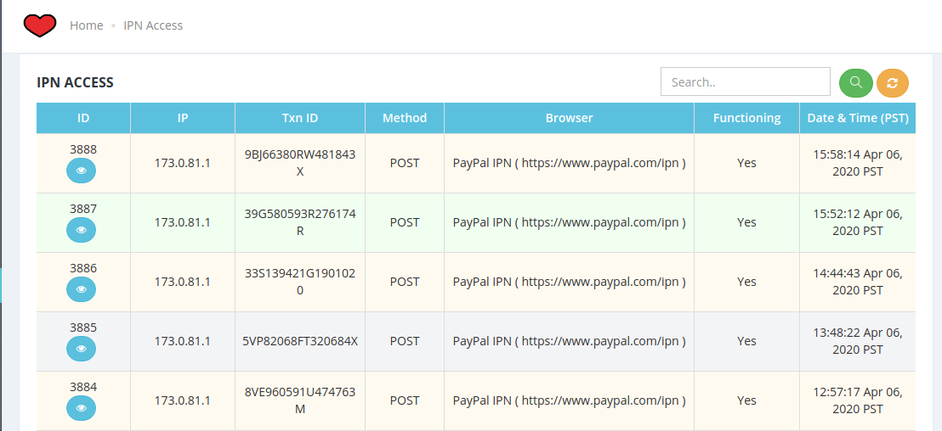

**Settings**

1. **Community Admin Email Template:**
   1. **Weekend Overbooked Email:**

This email received Community admin when any weekend overbooked.

* 1. **Feature update Email:**

This Email was received when a new feature was added by super admin. This email only received community Admin.

1. **Community Email Sample:**

Here showing all community email templates as samples. When a community clicks a sample from the community -> settings this template text automatically pastes in the community setting page.

**Features**

New features added in this page and all communities get this feature and feature details.

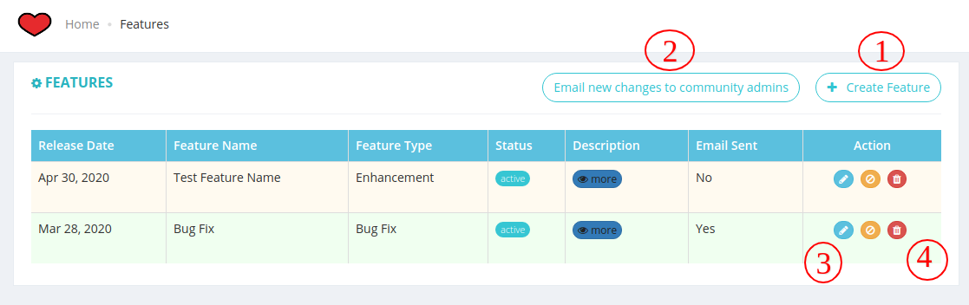

1. **Create Feature:** Here Super Admin can create new features.

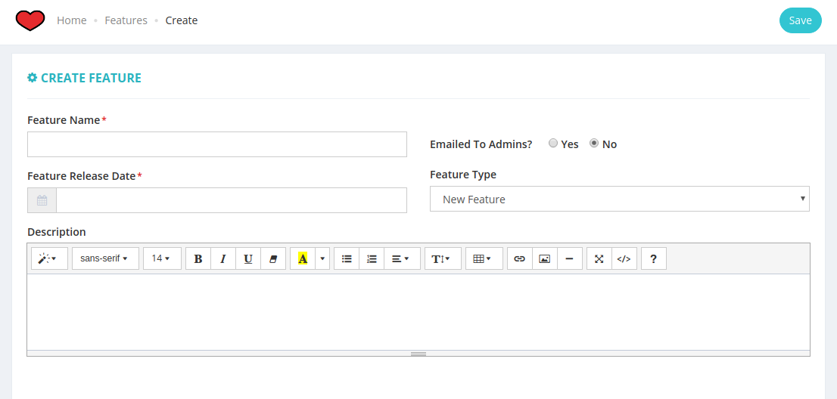

1. **Email New Changes to All Community Admin:** Send email with details feature information for all community admin.
2. **Edit Feature:** This edit button can edit and update any features information.
3. **Delete Feature:** Delete any feature in this button.